**Lab 4**

***(Show input and output side by side for all problems****)*

1. Sharpen the following image by applying,
2. Unsharp Masking
3. High Boost Filtering

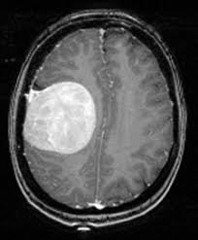

1. Sharpen the following image using the concept of Laplacian Filtering.

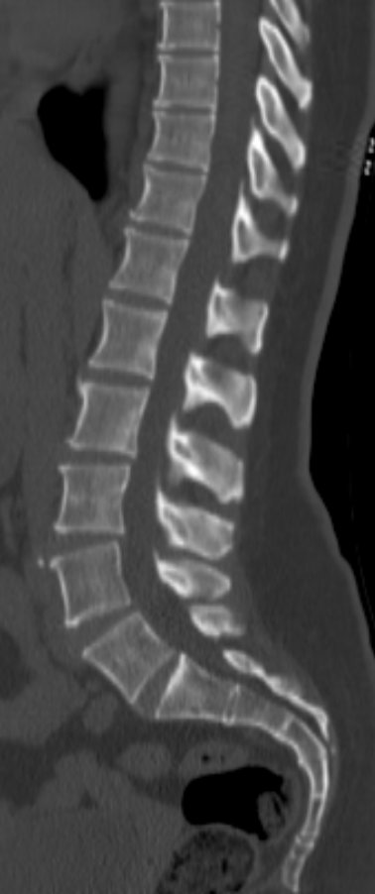

1. Use Roberts-cross operators to detect the edge of the following image.

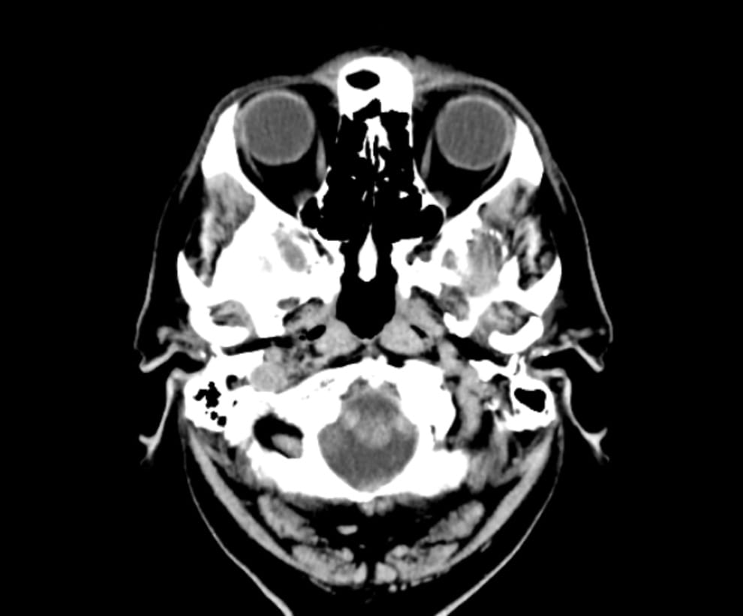

1. Use Sobel operators to detect the edge of the image from problem 3.
2. Use Prewitt operators to detect the edge of the image from problem 3.